OBSERVATION1:

Validation is not in account payable but it is there in account receivable.

Account payable: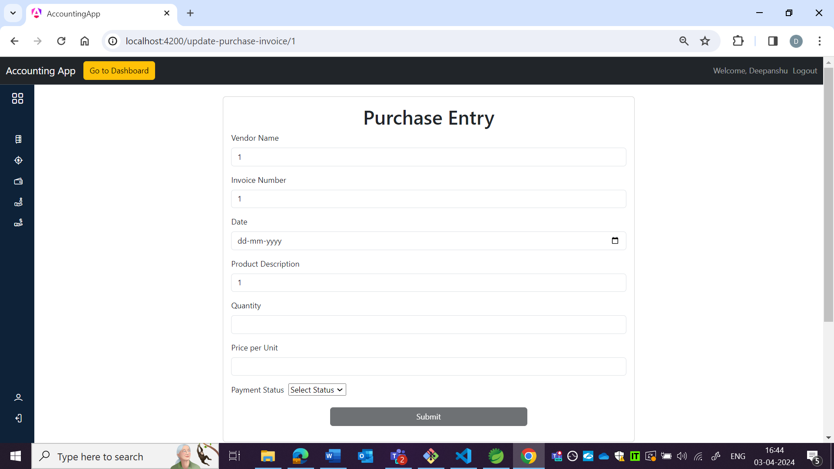

Account receivable: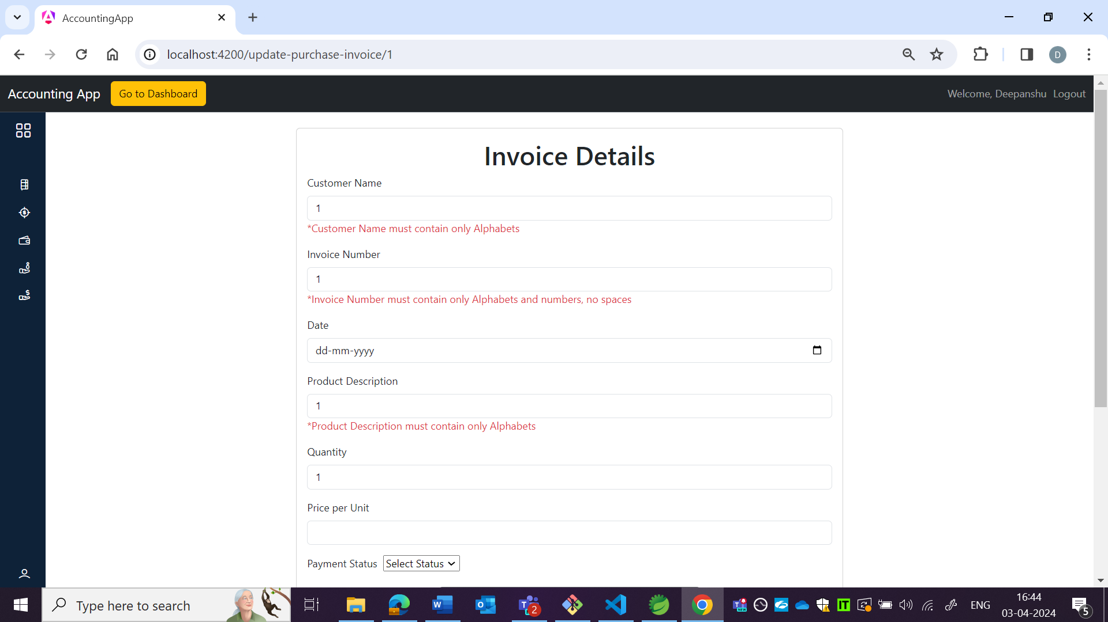

OBSERVATION2:

Able to update invoice number.

